

**Shaheed Zulfikar Ali Bhutto Institute of Science and Technology**

**Department of Software Engineering**

**Bisma Saeed – 2280108**

**BSSE – 7A**

**Lab: 01**

**. .**

**Task 1: Create the virtual machine**

1. Sign-in to the Azure portal: <https://portal.azure.com>
2. From the All services blade in the Portal Menu, search for and select Virtual machines, and then click +Create and choose +Azure Virtual machine from the drop down.

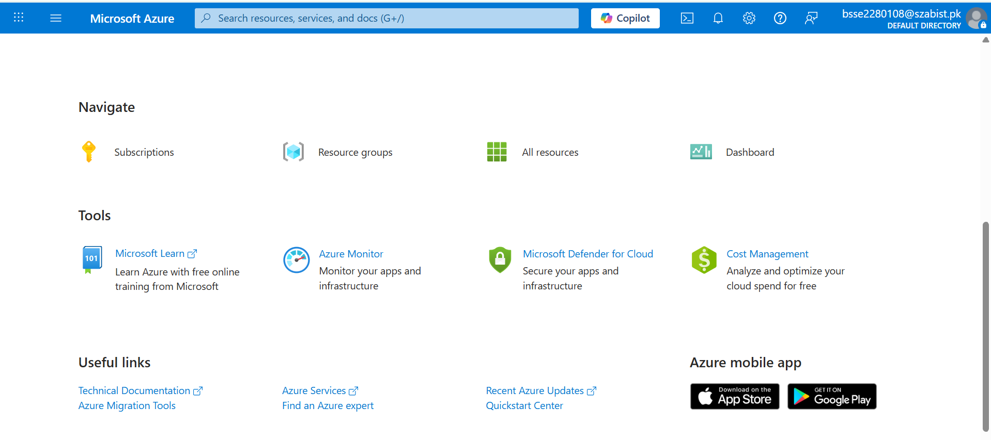

1. On the Basics tab, fill in the following information (leave the defaults for everything else):

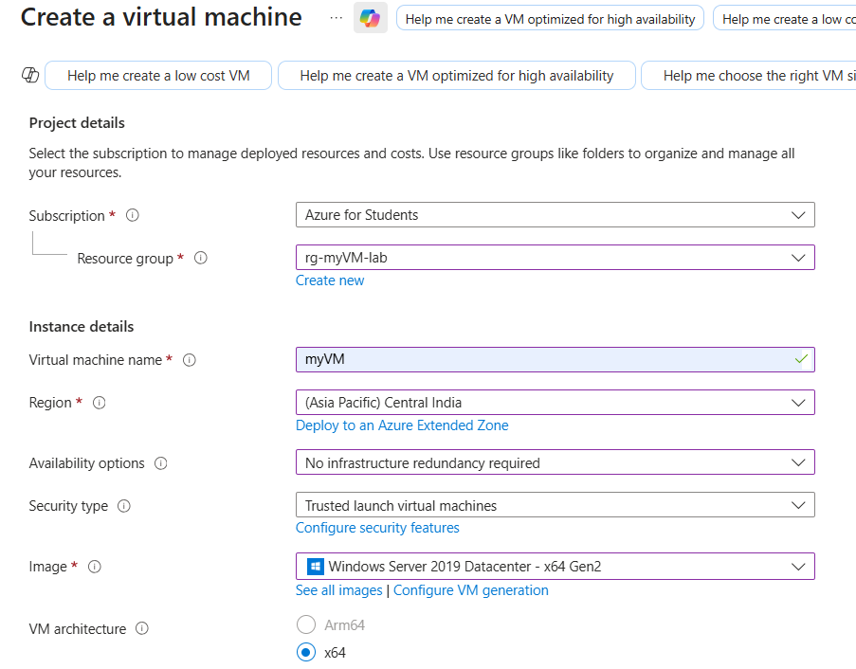

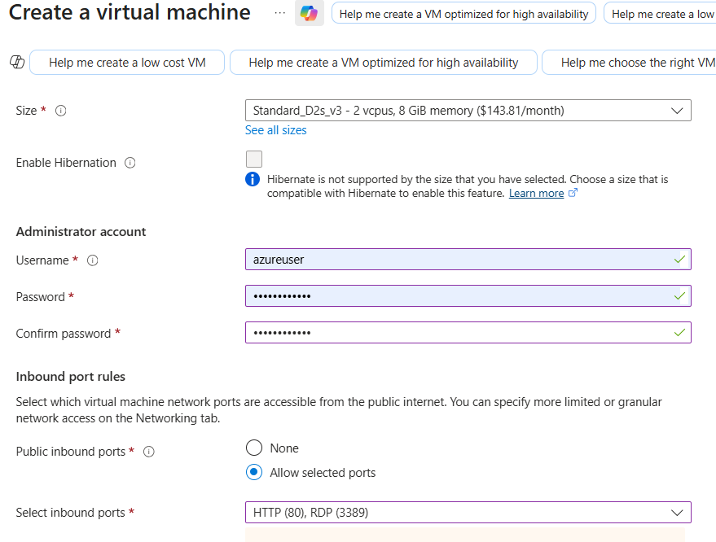

Pa$$w0rd1234

1. Switch to the Networking tab to ensure HTTP (80) and RDP (3389) are selected in section Select inbound ports.

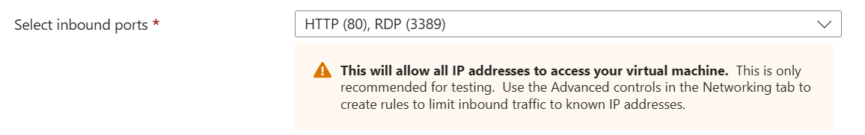

1. Switch to the Management tab, and in its Monitoring section, select the following setting:

Settings Values: Boot diagnostics Disable

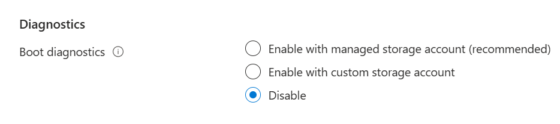

1. Leave the remaining values on the defaults and then click the Review + create button at the bottom of the page.

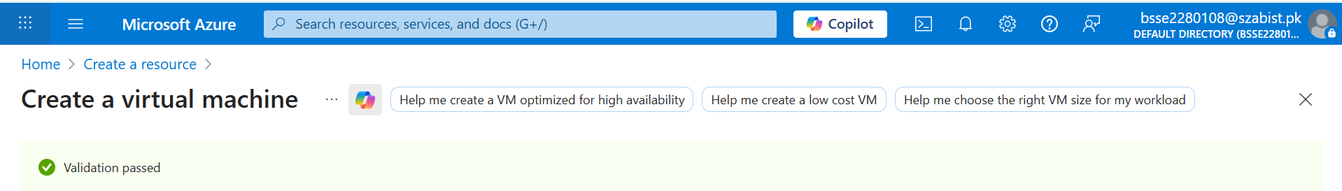

1. Once Validation is passed click the Create button. It can take anywhere from five to seven minutes to deploy the virtual machine.

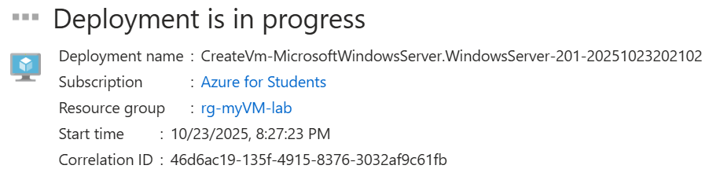

**Task 2: Connect to the virtual machine**

1. Click on bell icon from the upper blue toolbar, and select ‘Go to resource’ when your deployment has succeeded.

Note: You could also use the Go to resource link on the deployment page

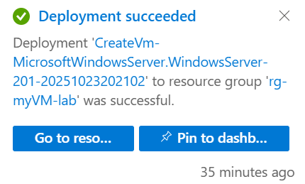

2. On the virtual machine Overview blade, click Connect button and choose RDP from the drop down.

3. On the Connect to virtual machine page, keep the default options to connect with the public IP address over port

3389 and click Download RDP File. A file will download on the bottom left of your screen.

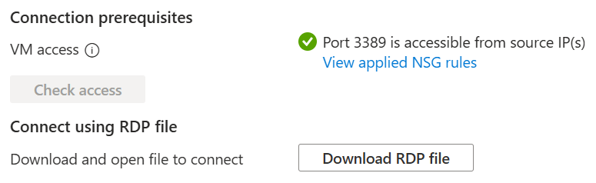

4. Open the downloaded RDP file (located on the bottom left of your lab machine) and click Connect when

prompted.

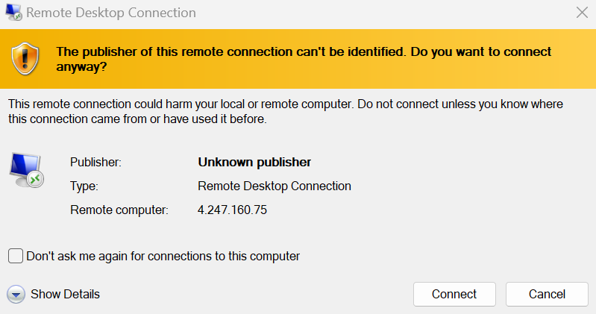

5. In the Windows Security window, sign in using the Admin Credentials you used when creating your VM azureuser

and the password Pa$$w0rd1234.

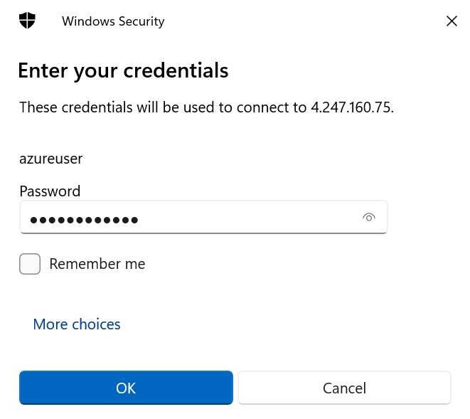

6. You may receive a warning certificate during the sign-in process. Click Yes or to create the connection and connect

to your deployed VM. You should connect successfully.

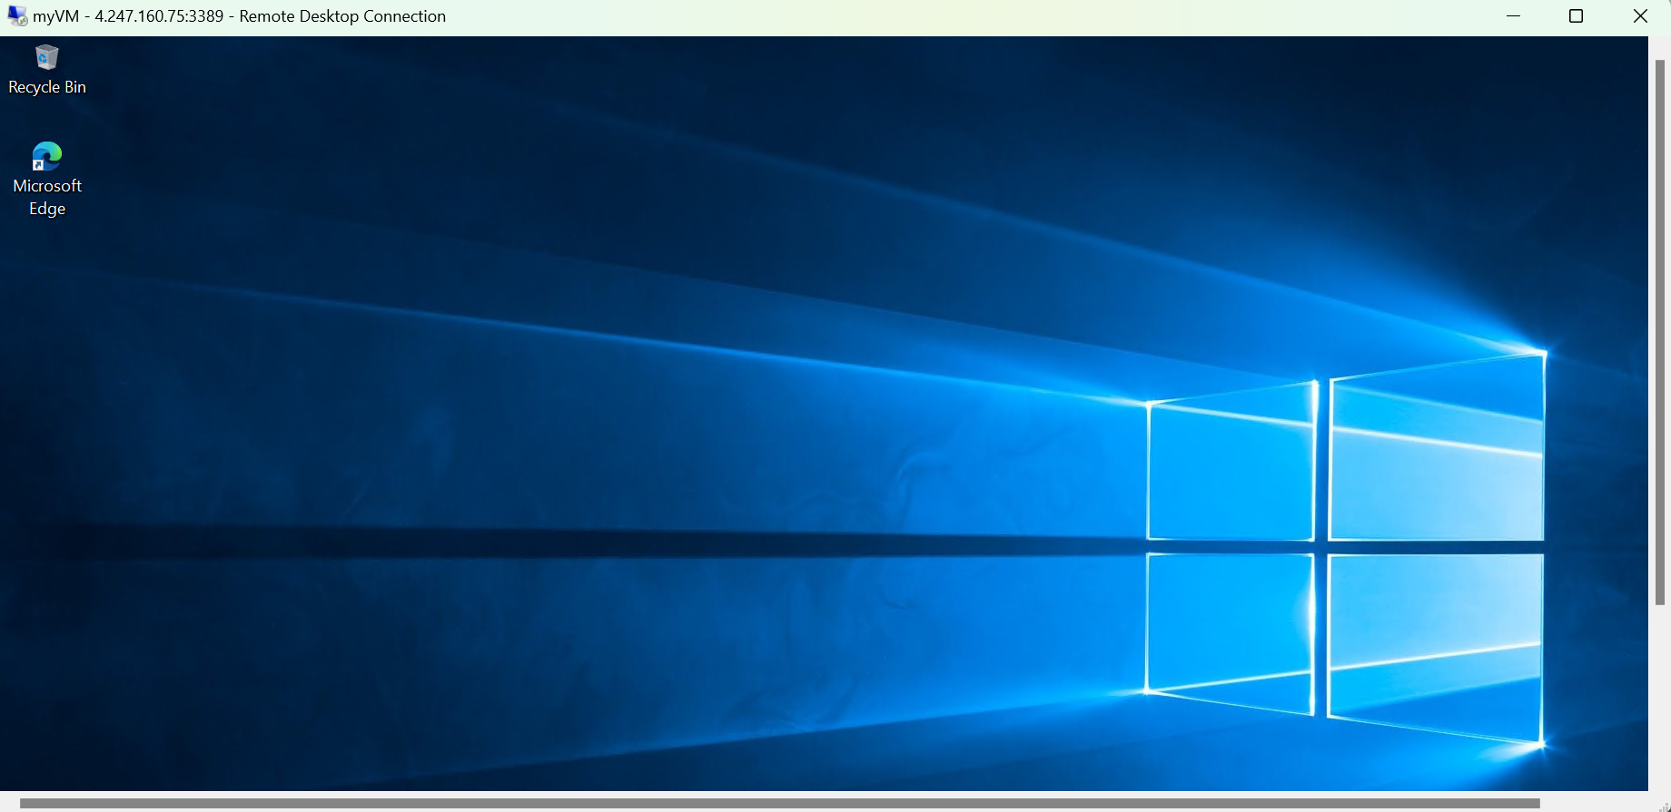

**Task 3: Install the web server role and test**

In this task, install the Web Server role on the server on the Virtual Machine you just created and ensure the default IIS

welcome page will be displayed.

1. In the newly opened virtual machine, launch PowerShell by searching PowerShell in the search bar, when found

right click Windows PowerShell to Run as administrator.

2. In PowerShell, install the Web-Server feature on the virtual machine by running the following command. (Paste

in the command and hit ENTER for the installment to begin).

Code: Install-WindowsFeature -name Web-Server -IncludeManagementTools

3. When completed, a prompt will state Success with a value True. You do not need to restart the virtual machine

to complete the installation. Close the RDP connection to the VM by clicking the x on the blue bar at the top center

of your virtual machine. You can also minimize it by clicking the - on the blue bar at the top center.

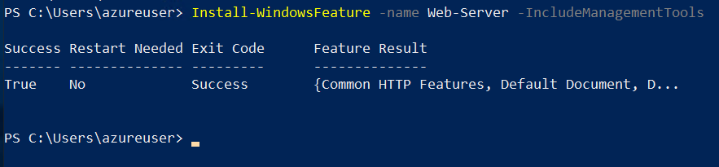

3. Back in the portal, navigate back to the Overview blade of myVM and, use the Click to clipboard button to copy

the public IP address of myVM, then open a new browser tab, paste the public IP address into the URL text box,

and press the Enter key to browse to it.

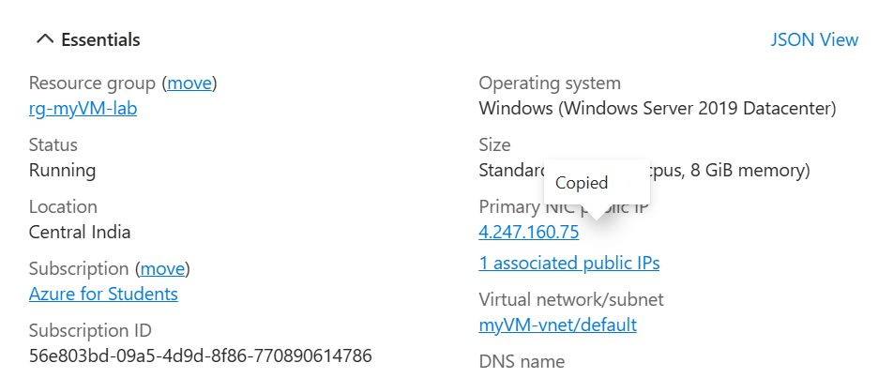

4. The default IIS Web Server welcome page will be displayed.

